
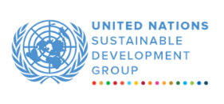
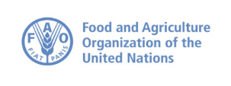
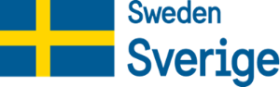


COMMUNITY-BASED FORESTRY AND PROTECTED AREA MANAGEMENT (CBFM) PROJECT
NARRATIVE progress report
REPORTING PERIOD: 1 january – 31 December 2025
Programme Title & Project Number |  |  | Country, Locality(s), Priority Area(s) / Strategic Results
Programme Title: Community-Based Forestry and Protected Area Management (CBFM)  Programme Number: 00133363  MPTF Office Project Reference Number: 00133701 |  |  | The CBFM Project is implemented in 7 counties: (Grand Cape Mount, Gbarpolu, Lofa, Grand Gedeh, River Gee, Sinoe, and River Cess) within the North-West and South-East Landscapes of Liberia.
Priority Area/ Strategic Results
UNCF Output 3.1: Laws and policies, regulatory and other frameworks that underpin sustainable agri-food and industrial systems, employment, environment, and climate action are strengthened and implemented to ensure gender-responsive economic growth and diversification, value addition, productivity, and livelihood.

UNCF OUTCOME INVOLVING UNDP CPD Outcome 3: By 2030, people in and of Liberia, especially children, young persons, women and people with disabilities benefit from an economic model that is founded on synergy among socio-economic and environmental policies and systems, lifted out of poverty and enhancing their access to decent jobs and agri-food systems.
Participating Organization(s) |  |  | Implementing Partners
- United Nations Development Programme  - United Nations Food and Agriculture Organization |  |  | - The Forestry Development Authority (FDA)
Programme/Project Cost (US$) US$7,523,817.06 |  |  | Programme Duration
Total approved budget as per project document:  MPTF /JP Contribution:  - by Agency (if applicable)  UNDP: 3,745,119.91  FAO: 3,778,697.15 |  |  | Overall Duration (51 Months)
Agency Contribution  - by Agency (if applicable) |  |  | Start Date (31/10/2022)
Government Contribution  (if applicable) |  |  | End Date 25/05/2026)
Other Contributions (donors)  (if applicable) |  |  | Current End Date(31/08/2026)
TOTAL:
Programme Assessment/Review/Mid-Term Eval. |  |  | Report Submitted By
Assessment/Review - if applicable please attach  Yes No Date: dd.mm.yyyy  Mid-Term Evaluation Report – if applicable please attach  Yes No Date: 30.04.2025 |  |  | Name: Robert Senkungu  Title: Joint Programme Manager  Participating Organization (Lead): UNDP  Email address: robert.senkungu@undp.org

ACRONYMS AND ABBREVIATIONS

AFC : Authorized Forest Community

CBFM : Community-Based Forestry and Protected Area Management

CDA : Cooperative Development Agency of Liberia

CF : Community Forest

CSO : Civil Society Organization

FAO : Food and Agriculture Organization of the United Nations

FDA : Forestry Development Authority

FCI : Foundation for Community Initiative

IPs : Implementing Partners

IWL : Integrity Watch of Liberia

LCC : Liberia Cocoa Corporation

MPTF : Multi Partner Trust Fund Office

NGO : Non-Governmental Organization

PAs : Protected Areas

PADEV : Partners in Development

PPAs : Proposed Protected Areas

SDI : Sustainable Development Institute

SCNL : Society for the Conservation of Nature of Liberia

TNC : The Nature Compact

UNSDCF : United Nations Sustainable Development Cooperation Framework

UNDP : United Nations Development Programme

EXECUTIVE SUMMARY

The Community-Based Forestry and Protected Area Management (CBFM) Project is a four-year joint programme (2022-2026) implemented by the United Nations Development Programme (UNDP) and the Food and Agriculture Organization of the United Nations (FAO) in partnership with Liberia’s Forestry Development Authority (FDA) and administered by the Multi-Partner Trust Fund Office (MPTFO). Funded by the Embassy of Sweden with a total budget of USD 7.56 million, the project operates across seven forested counties, Gbarpolu, Grand Cape Mount, Lofa, Grand Gedeh, River Gee, Sinoe, and River Cess. The project delivers integrated results in sustainable forest management, biodiversity conservation, climate-resilient livelihoods, and inclusive economic development, while strengthening community forest governance and public institutional capacity.
In 2025, the project translated its joint UNDP–FAO approach into tangible results by combining governance, climate action, and inclusive livelihood programming with technical forestry, land-use planning, and forest-based value chain expertise. The FDA served as the central government partner, supported by civil society and community institutions. Key implementing partners included SCNL, PADEV, IWL, CDA, TNC, FCI, SDI, FTI, and iCampus Liberia, alongside national consultants supporting institutional strengthening and digital transformation at the FDA and EPA.
Forest governance and institutional strengthening outcomes were substantial. By December 2025, more than 10,000 community forest stakeholders across 18 clustered communities enhanced their capacities in community-based forest management. Six Community Forest Management Bodies (CFMBs) received targeted institutional support, achieving 90 percent of the project target. Governance legitimacy was reinforced through completion of the legally mandated nine-step process in six Applicant Forest Communities. Two Authorised Forest Communities (AFCs), Sarbo/Gbaepo/Putupo and Salayae had their Community Forest Management Plans (CFMPs) formally approved by the FDA and handed over for implementation. One applicant community (Glarro) was discontinued due to unresolved land tenure disputes. Across all seven counties, communities advanced in governance formation, forest demarcation, CFMP development, and livelihood roll-out. Forest monitoring and enforcement capacity increased in River Gee County, where 15 forest guards were reactivated after nearly three years of inactivity. Transparency gains were institutionalized through the operationalization of the TALKAY digital anti-corruption reporting platform at the FDA.
Biodiversity conservation and landscape restoration delivered measurable environmental benefits. A total of 6,000 indigenous tree seedlings were planted on 60% of the 55 hectares of degraded land identified as impacted by human activities and agricultural encroachment, contributing to the rehabilitation of the ecology of the Lake Piso Sustainable Use Reserve. Participatory protected area management was strengthened through joint patrols involving the deployment of ecoguards and forest rangers. Conservation awareness activities reached 1,200 community members, including through the mobilization of 20 female Eco-Champions who promote sustainable forest management, biodiversity protection, and climate action.
The project also generated concrete gains in climate-resilient livelihoods and inclusive economic development. Communities were supported in lowland rice production, cassava value addition, vegetable farming and post-harvest handling, beekeeping, cocoa agroforestry, and Village Savings and Loan Associations (VSLAs) operations. Under the oversight of the Cooperative Development Agency, four producer groups, Yandohun, Lukasu, Kailahun, and Bamballa achieved full cooperative status, strengthening access to markets and finance. The Yandohun Cooperative Society participated in the December 2025 National Agriculture Fair in Ganta, showcasing locally produced country rice and strengthening market linkages.
Institutional capacity building and enabling infrastructure progressed concurrently. A comprehensive FDA Capacity Gap Assessment was finalized and operationalized through a Training of Trainers programme for 75 staff, strengthening internal knowledge transfer and sustainability. Two upgraded forestry nursery sites in Grand Gedeh and Lofa produced planting stock that boosted community restoration efforts.
Infrastructure investments advanced, including the construction of three community warehouses, a poultry facility in Salayae, and small ruminant facilities in Grand Gedeh and Lofa getting to advanced stages. Procurement of three solar-powered rice mills was completed, with delivery expected in March 2026, while solar irrigation systems were at the final procurement stage for delivery by May 2026. Beekeeping initiatives in Yerpuah, Gorlu, and Ganglota were fully implemented, and cocoa agroforestry systems in Telemu and Dweh Town continued to expand.
Overall, in 2025, the CBFM Project delivered coherent outcomes across forest governance, biodiversity conservation, livelihood resilience, institutional capacity, and community infrastructure, while advancing inclusivity and participation. Implementation delays were experienced in infrastructure-related livelihood activities and the roll-out of CFMPs, primarily due to statutory approval processes.

Purpose

The main purpose of this annual report is to document and communicate the 2025 annual progress, achievements, financial status, and challenges of the Community-Based Forestry and Protected Area Management (CBFM) Project to key stakeholders, including the donor, government partners, UN agencies, and implementing partners.

The report provides a comprehensive account of project implementation, highlighting activities undertaken and results achieved in forest governance, biodiversity conservation, climate-resilient livelihoods, institutional strengthening, and infrastructure development. It presents detailed financial information, including funds disbursed, expenditures, unspent balances, and remaining traches, ensuring accountability and identifying any pending commitments or financial risks. The report has a table which gives the cumulative status of the indicators.

By providing evidence-based insights, the report is expected to support decision-making and strategic adjustments by project partners to ensure continued delivery of results. Finally, it demonstrates compliance with donor requirements, alignment with Liberia’s national priorities, the UN Sustainable Development Cooperation Framework, and Sweden’s development cooperation strategy, while showcasing measurable impacts on communities and ecosystems. In essence, this annual report serves as both a performance report and an accountability tool, promoting transparency, learning, and informed guidance for the remainder of the CBFM Project.

The project’s goal is to balance forest conservation with economic development by: developing sustainable alternative livelihoods to reduce dependence on forest resources, strengthening community forest management (CFM) governance and institutional capacity, enhancing biodiversity data and improving forest management planning, promoting inclusive, sustainable business development for forest and farm producers (with a focus on non-timber forest products, or NTFPs, and local value chains), and integrating gender equity while involving local communities in the decision-making process.

Progress Towards Development Results

Progress Towards Achieving Results: Outcomes and Outputs:

The Community-Based Forestry and Protected Area Management (CBFM) Project is designed to achieve four(4) outcomes and thirteen (13) outputs over the short- to medium-term. Each outcome is directly linked to specific outputs, collectively contributing to the overarching goal of strengthening community forest management, biodiversity conservation, climate-resilient livelihoods, and knowledge management. During the reporting period, implementation advanced steadily, with tangible progress recorded across all outcomes.

Outcome 1.1: Strengthened Institutional and Community Capacity and Regulatory Framework for Community Forest Management

Implementation under Outcome 1.1 advanced community forest governance, strengthened legal and regulatory frameworks, and enhanced transparency and accountability mechanisms at both community and national levels.
Under Output 1.1.1a, Existing local governance institutions [CFMBs/ Community-Based Organizations (CBOs) and Conservancy-based forums strengthened by re-vitalizing their functioning and governance capacity building
Six out of the seven Community Forest Management Bodies (CFMBs) received targeted capacity-building support, representing approximately 90 percent achievement of the planned target. Significant progress was made in advancing the community forestry authorization process, with Kiteapo reaching Step 9 of the nine-step process and its Community Forest Management Plan (CFMP) reviewed by the Forestry Development Authority (FDA), while CFMA signing scheduled for December 2025 delayed due to FDA formality. Five additional applicant communities, Mafalla, Gbarma Lumeh, Torkpoima, Wassea, and Solowoloh also reached Step 9, with bylaws and CFMPs submitted to the FDA for final review. One applicant community, Glarro, was discontinued due to unresolved land tenure conflicts.
Transparency and accountability in forest governance were further strengthened through the deployment of the TALKAY (https://forestry.talkay.org/) digital anti-corruption reporting platform. The platform has been installed at the FDA, with both staff and community members trained in its use. FDA has designated a dedicated staff member to manage real-time reporting and data tracking.

Key Activities that contributed towards achieving Output 1.1.1
During the period under review, the following activities contributed to achieving output 1.1.1:
- Conducted governance and leadership training for CFMB members
- Supported Community Assembly elections and leadership transitions
- Facilitated bylaw drafting and validation processes
- Provided technical guidance to applicant communities through Steps 8-9 of the CFMA process
- Developed, deployed, and operationalized the TALKAY anti-corruption reporting platform
- Trained FDA staff and community representatives on digital accountability tools

Under Output 1.1.2, Community Forest Management Plans of existing authorized forest communities (AFC)/CFMBs are updated to reflect current reality.

Two Community Forest Management Plans for Sarbo/Gbaepo/Putupo and Salayae received FDA approval and were handed over to the communities for implementation.

Key Activities that contributed towards achieving Output 1.1.2
During the period under review, the following activities contributed to achieving Output 1.1.2:
- Provided technical assistance for CFMP drafting and revision
- Facilitated community consultations during CFMP development
- Supported FDA review and submission processes
- Guided CFMBs on CFMP implementation planning

Output 1.1.3 Legal/policy frameworks simplified
During the reporting period, Community Assembly elections were held for the six and the reactivation of forest guards following prolonged periods of inactivity. At the national level, the Community Forestry Working Group (CFWG) was revitalized and conducted site-based verification visits, advancing communities such as Kiteapo/River-Gbeh toward final CFMA signing.

Key Activities that contributed towards achieving Output 1.1.3
- Simplified and translated key forest and land laws into user-friendly formats
- Conducted community sensitization and legal awareness sessions
- Supported Community Assembly elections in authorized forest communities
- Reactivated and supported Forest Guards for forest monitoring
- Revitalized the Community Forestry Working Group and supported verification visits

Outcome 2.1: Improved Status of Key Species and Habitats through Participatory Forest Management and Biodiversity Conservation

Under Outcome 2.1, the project contributed towards strengthening participatory forest management and biodiversity conservation through co-management arrangements, restoration interventions, and improved monitoring systems.

Output 2.1.1, Co-management of selected Protected Areas implemented through tripartite (Government, CBOs, and conservation NGOs) agreements and terms of partnerships.

To strengthen collaborative conservation efforts, joint patrols involving the deployment of eco-guards and forest rangers continued and a reduction of 30% in illegal penetration was registered.

Key Activities that contributed towards achieving Output 2.1.1
- Supported deployment and orientation of eco-guards
- Joint eco-guards and forest ranger patrols

Output 2.1.2 FDA-Community reforestation by planting targeted hectares of indigenous trees in degraded patches of forest landscapes in PAs, including areas affected by artisanal mining and agriculture

This output focuses on forest restoration and rehabilitation of degraded landscapes. During the reporting period, 6,000 indigenous tree seedlings were planted across 55 hectares of degraded forest areas, including sites affected by artisanal mining and agricultural encroachment in Lake Piso Multiple Use Reserve, rehabilitating approximately 65 percent of the targeted restoration area. These interventions are expected to contribute to improved habitat quality and ecosystem recovery.

Key Activities that contributed towards achieving Output 2.1.2

- Identified and mapped degraded restoration sites
- Produced and distributed indigenous tree seedlings
- FTI with grant from UNDP established and/or upgraded Tree Nurseries in the Community based Forestry and Protected Areas within Lofa and Grand Gedeh counties respectively.
- Conducted land preparation and planting activities
- Engaged communities in restoration and site monitoring

Output 2.1.3, Capacity support to FDA/communities, including remote sensing technologies, carbon monitoring tools to promote biodiversity and forest monitoring increased.

Progress was made in strengthening institutional capacity for participatory biodiversity and forest monitoring through the deployment of climate and knowledge-based monitoring tools. The Environmental Knowledge Management System (EKMS) at EPA was fully restored and upgraded and is now functional (https://ekmsliberia.info/). Forest Data Collection and Reporting System for the Forestry Development Authority (FDA) was operationalized (http://monitoring.fda.gov.lr/).

Key Activities that contributed towards achieving Output 2.1.3 are as follows:
- Procured and deployed GIS and remote sensing tools
- Supported installation of Climate Cloud and the EKMS platforms restoration which is ongoing
- Trained technical staff on GIS, map-layer analysis, and forest-climate monitoring
- Developed forest-climate reference maps and dashboards

Outcome 3.1: Climate-Resilient Livelihood Options Diversified and Strengthened
Implementation under Outcome 3.1 addressed the socio-economic drivers of deforestation by promoting diversified, climate-resilient livelihood opportunities and strengthening forest-based enterprises and led to a 60% increase in income.

Output 3.1.1, Strengthened climate resilience and productivity for crop and livestock management.

Seven climate-resilient livelihood initiatives were introduced, including lowland System of Rice Intensification (SRI) rice farming, beekeeping, cocoa agroforestry, plantain and pigeon pea intercropping, black pepper harvesting, small ruminant rearing, and vegetable farming.

Victoria Young and her husband, Daniel, are among the project beneficiaries and manage a one-acre family farm. They didn't wait for the rain; during the dry season, they manually drew water (with tools provided by the project support) from nearby streams to sustain their plantain and pepper crops.

“With the way I see the plants growing now, I am hopeful that I will harvest way more than I usually do,” Victoria explains. …“the project taught us how to plant in straight lines and use nurseries for the pepper before transplanting them.”

The key activities that contributed to achieving Output 3.1.1 are as follows:
- Introduced climate-smart crops and livestock production models
- Distributed starter inputs and farming tools
- Provided extension and technical training to beneficiaries
- Supported demonstration plots and farmer-to-farmer learning
- Constructed 2 small ruminant facilities in Salayea and Konobo, and conducted training for beneficiaries
Output 3.1.2 Community livelihoods improved, and sources of income diversified and enhanced

This output contributed to improved household incomes and financial inclusion, reaching over 3,022 beneficiaries, of whom 65 percent were women. Beneficiaries engaged in Village Savings and Loan Associations (VSLAs), cassava processing, non-timber forest product (NTFP) enterprises, and small livestock production, resulting in diversified income sources. Four producer organizations (Yandohun, Lukaso, Kalahun, and Bamballa) upgraded to full cooperative status.

Key Activities that contributed towards achieving Output 3.1.2
- Established and strengthened Village Savings and Loan Associations
- Supported cassava processing, NTFP enterprises, and small livestock production
- Facilitated cooperative formation and registration processes
- Delivered financial literacy and group governance training

Output 3.1.3, Increased value chain specific assessment (VCA) based post-harvest services

The project supported 20 community forest-based micro, small, and medium enterprises (MSMEs) through the iCampus growth accelerator. These enterprises received business development support, mentorship, and linkages to grants and financial institutions, enhancing their operational capacity and market readiness. a training of trainers targeting 100 participants (54 M / 46 F) was conducted on sustainable production standards and criteria.

Key Activities that contributed towards achieving Output 3.1.3
- Delivered business development and entrepreneurship training
- Provided mentorship and coaching to MSMEs
- Linked enterprises to grants and financial institutions
- Monitored enterprise performance and milestones

Output 3.1.4 Market and finance access enhanced

This output focuses on strengthening enabling infrastructure for value addition and post-harvest management. Construction and procurement processes for animal rearing structures, community warehouses and post-harvest processing facilities commenced and are at various levels of completion. More than 350 women in the Southeast landscape received advanced trained in VSLA and this year they mobilized $1,150 in finances which boosted their livelihoods.

Key Activities that contributed towards achieving Output 3.1.4 are as follows:
- Conducted technical assessments and site selection
- Procured rice mills and processing equipment
- Initiated construction of warehouses and post-harvest facilities
- Monitored contractor performance and construction progress
- Procure power tiller, seeds (improved Cocoa, vegetables), farming equipment, and tools for livelihood interventions in Salayea (Lofa) and Konobo (Grand Gedeh)

Outcome 4.1: Strengthened Knowledge Management to Support Gender-Balanced Community Forest Management and Co-Management of Protected Areas

Under Outcome 4.1, the project strengthened knowledge generation, dissemination, and gender-responsive learning systems to support sustainable forest management.

Output 4.1.1 Enhanced generation of lessons learned best practices and KM products for dissemination with professionals and local communities

Over 3,000 knowledge management products are generated and disseminated among forest communities, practitioners, and institutions.

Key Activities that contributed towards achieving Output 4.1.1 as follows:
- Documented lessons learned and best practices
- Produced manuals, briefs, and guidance notes
- Disseminated KM products to communities and institutions

Output 4.1.2 : A mix of user-friendly multi-media outputs and contents produced for conservation activities.

A total of 3,500 user-friendly multimedia materials continued to be used, reaching approximately 10,000 people with conservation awareness and education messages. The theatre troupe reached disseminated environment-related messages to communities in River Gee. Facebook posts sgared project-related information.

Key Activities that contributed towards achieving Output 4.1.2 as follows:
- Produced radio, print, video, and digital content
- Conducted community awareness events and theatre performances
- Mobilized Eco-Champions for grassroots outreach

Output 4.1.3, A gender mainstreamed participatory MEL strategy developed and implemented to facilitate adaptive project management decision making.
A gender-mainstreamed participatory Monitoring, Evaluation, and Learning (MEL) strategy was integrated and reviewed, achieving full completion. Gender considerations are increasingly referenced in adaptive project management and decision-making processes. Community engagement activities reached more than 1,000 beneficiaries through Eco-Champions, awareness campaigns, and theatre performances, with women playing prominent leadership roles across VSLAs, community governance structures, and enterprise development initiatives.

Key Activities that contributed towards achieving Output 4.1.3 are as follows:
- Conducted gender analysis across project
- Developed gender-mainstream MEL tools and indicators
- Sensitized partner and community forests beneficiaries on gender-responsive monitoring
- Integrated gender insights into management decisions

- Qualitative Assessment of Project Achievement

Overall, project activities are contributing to improved institutional coordination, stronger community participation in forest management, and increased awareness of sustainable natural resource use. While some interventions remain ongoing, the qualitative evidence suggests that the project is moving in a positive direction toward achieving its intended outcomes. https://l.facebook.com/l.

Under the outcome focused on strengthening institutional and community capacity for community forest management, the project has contributed to notable improvements in governance structures and regulatory processes. Community Forest Management Bodies have received targeted training and technical guidance, which has helped strengthen leadership, governance practices, and community participation in decision-making processes. The progress achieved in advancing several communities through the Community Forest Management Agreement authorization process reflects growing local ownership and improved readiness for formalized forest governance. The deployment of the TALKAY digital reporting platform has also introduced a new level of transparency and accountability within the forestry sector, enabling both community members and government staff to report governance concerns and track responses in real time. In addition, the simplification of key legal and policy frameworks has helped communities better understand their rights and responsibilities in managing forest resources. These efforts collectively demonstrate progress in building stronger and more inclusive governance systems at both the community and national levels.

The project has also made important contributions toward improving the conservation of key species and habitats through participatory forest management approaches. Collaborative partnerships between government institutions, civil society organizations, and local communities have been strengthened through the establishment of co-management arrangements that support protected area management. The deployment of eco-guards has enhanced monitoring presence in targeted conservation areas, while restoration activities in degraded forest landscapes are beginning to contribute to ecosystem recovery. Community engagement in restoration efforts has not only supported environmental rehabilitation but has also strengthened local stewardship of forest resources through the incentivized approach (https://bit.ly/47Lq9ve).

In addition, the introduction of digital tools for forest and climate monitoring has strengthened the technical capacity of national institutions to collect, analyze, and use environmental data. These initiatives collectively support more informed decision-making and reinforce collaborative approaches to biodiversity conservation.

Progress under the livelihood diversification outcome indicates that the project is beginning to address some of the underlying economic pressures that contribute to forest degradation. By introducing climate-resilient agricultural practices, agroforestry systems, and small-scale enterprise opportunities, the project is supporting communities to adopt alternative and sustainable income-generating activities. Beneficiaries have received training, tools, and technical support that enable them to improve productivity and diversify their livelihood strategies. The establishment of Village Savings and Loan Associations and the formation of cooperative groups have strengthened financial inclusion and collective economic participation, particularly for women and youth. Support provided to community-based micro, small, and medium enterprises has further enhanced entrepreneurship and business development capacities within forest communities. Although infrastructure for post-harvest management and value addition is still under development, these initiatives are expected to further strengthen market access and income stability once completed.

The project has also demonstrated strong progress in knowledge management and community awareness. Through the production and dissemination of various knowledge products, the project has facilitated the sharing of lessons learned, technical guidance, and best practices among communities, practitioners, and institutions. Conservation awareness campaigns and outreach activities have reached large numbers of people across project landscapes, helping to increase public understanding of sustainable forest management and biodiversity protection. The use of multiple communication channels, including community events, media products, and grassroots outreach through Eco-Champions has strengthened the reach and effectiveness of these awareness efforts. The integration of gender-responsive monitoring, evaluation, and learning approaches has strengthened the project’s ability to capture lessons and adapt implementation strategies. Increasing participation of women in governance structures, savings groups, and livelihood initiatives reflects gradual progress toward more inclusive and equitable project outcomes.

Taken together, these achievements indicate that the project is building a strong foundation for sustainable community forest management and conservation outcomes. Institutional systems are becoming more responsive, communities are increasingly engaged in managing forest resources, and livelihood alternatives are beginning to reduce reliance on unsustainable forest exploitation. While continued efforts will be required to complete ongoing infrastructure, finalize regulatory processes, and scale up livelihood impacts, the qualitative evidence from the reporting period suggests that the project is making steady and meaningful progress toward its development objectives.

The project conducted a mid-term review which concluded that a strong foundation had been established for sustainable forest management and community empowerment. This was particularly evident in the project’s support to communities navigating Liberia’s formal nine-step process for establishing authorized forest communities, including the formation of Community Forest Management Bodies (CFMBs) as core governance structures. The review recommended strengthening institutional frameworks, scaling up livelihood initiatives, reinforcing participatory monitoring and accountability mechanisms, and enhancing targeted support for marginalized groups to promote more inclusive and resilient outcomes. Building on these lessons and the resource envelop, the project commenced out scaling the VSLA model.

- Cross-Cutting Issues:
Cross-cutting issues such as gender equality, community participation, governance transparency, environmental sustainability, and institutional collaboration were integrated throughout the implementation of the Community-Based Forestry and Protected Area Management (CBFM) Project. These elements helped ensure that project activities not only addressed environmental objectives but also promoted inclusive participation, accountability, and long-term sustainability within forest-dependent communities.

Gender equality and women’s empowerment remained an important focus of project implementation. Women actively participated in livelihood interventions, Village Savings and Loan Associations (VSLAs), and cooperative groups, which strengthened their economic engagement and decision-making roles within communities. Gender-responsive approaches were also incorporated into the project’s Monitoring, Evaluation, and Learning (MEL) framework, allowing gender considerations to inform project planning, monitoring, and adaptive management. Increasing participation of women in community governance structures and livelihood initiatives reflects progress toward more inclusive and equitable development outcomes.
Community participation and local ownership were central to the project’s implementation strategy. Communities were actively involved in consultations, planning processes, restoration activities, and forest monitoring efforts. Their engagement in the development of Community Forest Management Plans and conservation initiatives helped strengthen local ownership of forest resources and enhanced commitment to sustainable forest management practices.

The project also promoted transparency and accountability in forest governance. The introduction of the TALKAY digital anti-corruption reporting platform provided a mechanism for reporting and tracking governance concerns within the forestry sector, thereby improving transparency and strengthening institutional accountability. In addition, the simplification and dissemination of forest and land governance frameworks enabled communities to better understand their rights, responsibilities, and legal procedures related to community forestry.
Environmental sustainability and climate resilience were integrated across several project interventions. Forest restoration activities, participatory monitoring systems, and climate-resilient livelihood initiatives contributed to reducing pressure on forest ecosystems while promoting sustainable resource use. Together, these cross-cutting approaches strengthened the overall effectiveness of the project and supported more inclusive, transparent, and environmentally sustainable forest management outcomes.

- UN Coordination and Support:
The implementation of the Community-Based Forestry and Protected Area Management (CBFM) Project benefited from strong coordination among United Nations agencies, national institutions, and implementing partners. UNDP provided overall strategic leadership, technical guidance, and coordination to ensure that project activities remained aligned with Liberia’s national development priorities and environmental commitments. Through continuous engagement with key government institutions, particularly the Forestry Development Authority (FDA) and the Environmental Protection Agency (EPA), the project strengthened collaboration on community forest governance, biodiversity conservation, and climate resilience initiatives.

The JP facilitated coordination among implementing partners to ensure that project activities were implemented efficiently and in alignment with national policies and strategies. Regular consultations and technical support helped strengthen institutional capacity, improve planning and monitoring processes, and promote knowledge sharing among stakeholders involved in forest management and conservation. A successful Steering Committee meeting was held in July 2025, resulting in the approval of the project’s Year 4 work plan and budget.

Overall, UN coordination and support played a critical role in enhancing collaboration among government institutions, UN agencies, and non-governmental organizations. This integrated approach contributed to effective project implementation, strengthened institutional capacity, and supported sustainable outcomes in community forest management, biodiversity conservation, and climate-resilient livelihoods.

Cumulative Indicator Based Performance Assessment:

Indicators | Achieved Indicator Targets | Reasons for Variance with Planned Target (if any) | Source of Verification
Outcome 1.1: Strengthened Institutional and Community Capacity and Regulatory Framework for Community Forest Management.  Indicator 1.1: Number of communities with strengthened capacities and regulatory framework in place for Community Forest Management (CFM)  Baseline 0  Target: 20 | 100% achieved-  All 20 forest communities, comprising several towns capacities have been strengthened with regulatory framework in place. These communities have enhanced their capacities in forest governance, leadership, and community-based forestry management. | No Variance | Training reports, community records, CFMB reports
Output 1.1.1 Existing local governance institutions [CFMBs/ Community-Based Organizations (CBOs) and Conservancy-based forums strengthened by re-vitalizing their functioning and governance capacity building.  Indicator 1.1.1a: Number of Community Forest Management Bodies (CFMBs) strengthened by revitalizing their functioning and governance system through capacity building  Baseline:0  Target: 10 | 90% Achieved-  Capacity building delivered to a total of 6 of the 7 applicant community forests and 3 authorized forest communities (AFCs). | N/A  One applicant community was dropped due to unresolved boundary conflicts. | CFMB training records, governance reports
Indicator 1.1.1b. Anti-corruption reporting platform/App developed and in use | 100% Achieved-  One Anti-corruption reporting platform (TALKAY) system setup/deployed at FDA, staff and community members trained; seconded FDA staff assigned to manage real-time tracking. | N/A | System deployment records, training attendance
Output 1.1.2 Community Forest Management Plans of existing authorized forest communities (AFC)/CFMBs updated to reflect current reality.  Indicator 1.1.2a: Number of Community Forests Management Plans (CFMPs) updated.  Baseline:0  Target:3 | 66.67% Achieved-  2 authorized CFMPs updated and shared with the communities. One was still active by time of reporting. | N/A | CFMP copies, FDA records
Indicator 1.1.2b: Number of persons/participants who are aware/sensitized on Community Forest Management.  Baseline:0  Target: At least 6,000 persons within the forest communities | 100% Achieved-  More than 6000 persons have been sensitized and are aware of Community Forest Management. | N/A | CFMB training records, governance reports, reports on community participation.
Output 1.1.3: Legal/policy frameworks simplified.  (Amendments/enabling the legal framework and policy instruments to enable a sustainable CBFM plan and submitted to the Government for adoption).  Indicator 1.1.3: Number of legal/policy frameworks simplified.  Baseline:0  Target:3 | Fully Achieved: Exceeded target; Community Rights Law, National Forest Reform Law, Conservation & Wildlife Law, Land Rights Act simplified. | N/A  N/A | Copies of Community Rights Law, National Forest Reform Law, Conservation & Wildlife Law, Land Rights Act simplified.
Outcome 2.1: Status of key species and their habitat improved due to participatory forest management and biodiversity conservation.  Indicator 2.1: Percentage increase in biodiversity conserved. (Proxy adopted=reduction in illegal incidents)  Baseline: 0  Target: Reduced illegal incidences. | 30% reduction in penetration of illegal activities. | FDA is using documented proxy indicators of illegal activities using Joint ranger and eco-guard patrol records. No wildlife surveys were conducted due to resource constraints. | joint patrol records for eco-guards abd forest rangers. .
Output 2.1.1: Co-management of selected Protected Areas implemented through tripartite (Government, CBOs, and conservation NGOs) agreements and terms of partnerships.
Indicator 2.1.1: Number of Tripartite co-management agreements signed.
Baseline:0
Target: 1

 | 100% Achieved-  1 agreement signed between  SCNL, FDA, and UNDP followed by the selection, training and deployment of eco-guards. | N/A | Copy of Tripartite agreement signed between  SCNL, FDA, and UNDP followed by the selection, training and deployment of eco-guards.
Output 2.1.2: FDA-Community reforestation by planting targeted hectares of indigenous trees in degraded patches of forest landscapes in PAs, including areas affected by artisanal mining and agriculture  Indicator 2.1.2a: Number of hectares reforested and restored in protected areas Baseline:0  Target: 55 ha | 55 ha identified: 65% rehabilitated and restoration ongoing | 55 hectares of degraded land identified at Lake Piso multiple-use reserve; a little over 6,000 indigenous trees planted.65% rehabilitated with restoration ongoing. | FDA, UNDP, FAO, SIDA joint field mission and monitoring reports
Indicator 2.1.2b: Number of institutions using collaborative forest monitoring equipment, including remote sensing technologies and carbon monitoring tools.  Baseline:0  Target: 2 institutions equipped (FDA and EPA) | 2. EPA and FDA. | EKMS restored and fully functional at EPA; Forest Conservation reporting webtool deployed and in use at FDA. | Web information on FDA and EPA climate cloud tools deployed and in use.
Output 2.1.3: Capacity support to FDA/communities, including remote sensing technologies, carbon monitoring tools to promote participatory biodiversity and forest monitoring.  Indicator 2.1.3: Use of a GIS-based map layer analysis, forest-climate reference system, and visualization tools in place.  Baseline:0  Target: At least 2 FDA technical staff trained in:  GIS map layer analysis, remote sensing for forest monitoring and forest climate reference mapping | 100% Achieved-  GIS and remote sensing technologies and others provided with two FDA staff were trained to provide continuous support. | N/A | Record of  GIS and remote sensing technologies and other provided
Outcome 3.1: Livelihood options for communities are made climate-resilient through diversification and entrepreneurship.  Indicator 3.1: Percentage increase in average annual household income derived from climate-resilient livelihood activities among beneficiaries in targeted forest communities.  Baseline:0  Target: 30% | 60% increase in average annual household income derived from climate-resilient livelihood activities adopted by beneficiaries’ households. | The communities rose from zero income from the farms to the current levels of production, hence substantially increasing income. | Joint field monitoring report
Output 3.1.1: Strengthened climate resilience and productivity for crop and livestock management.  Indicator 3.1.1: Number of climate resilient livelihood initiatives introduced and owned by beneficiaries around PAs, PPAs or Forest Fringe Communities.  Baseline:0  Target:10 | 90% Achieved-  9 Different climate resilient livelihood initiatives introduced (lowland SRI rice farming, beekeeping, Cocoa, Plantain/Pigeon Peas, black Pepper harvesting, vegetables, cassava, art and crafts, cane rat) | There were delays from the implementing partners due to lead time for clearing procurement and construction protocols (by UNDP & FAO) for other initiatives like small ruminants and poultry, which will be completed early 2026. | Joint field mission and quarterly annual reports
Output 3.1.2: Community livelihoods improved, and sources of income diversified and enhanced.  Indicator 3.1.2a: Number of beneficiaries with increased and diversified sources of incomes  Baseline:0  Target: 3,500 | 86.3% overall achieved, with 67.1% women, Scaling up ongoing with 3,022(2,027 women & 995 men) beneficiaries | N/A | Joint field mission and quarterly annual reports
Indicator 3.1.2b: Number of farmer cooperatives formed  Baseline:0  Target:10 | 40% fully achieved,  4 cooperatives attained full cooperative status (Yandohun, Lukaso, Kalahun, Bamballa), while the remaining 6 are still awaiting full status. | At the start of the project 18 producer groups were registered as pre-cooperatives. The Cooperative protocols dictate a phased approach, which may take more than the life of project. The project team identified most motivated pre-cooperatives which progressed to full cooperative status. | Joint field mission and quarterly annual reports
Output 3.1.3: Increased value chain specific assessment (VCA) based post-harvest services  Indicator 3.1.3: Number of small-scale infrastructure and equipment to facilitate storage and Agro-processing (storage, processing, packaging, testing/standardization) of agricultural and tree products are complete  Baseline:0  Target: 7 | 30% achieved-  3 rice mills are procured while 4 post-harvest facility procurement processes are ongoing. The procurement processes for the construction of Solar irrigation and post-harvest facility for vegetable producers in Salayea is also ongoing. | There were delays from the implementing partners due to procurement lead time for post-harvest equipment and construction (by UNDP and FAO). The remaining infrastructure will be completed by close of project. | Joint field monitoring mission and quarterly annual reports
Output 3.1.4: Market and finance access enhanced  Indicator 3.1.4: Number of agricultural MSME forest-based enterprises having access to business training and grants through the growth accelerator.  Baseline:0  Target: 20 | 100% achieved:  20 community-based enterprises in small business models assessed, identified, trained and linked to financial institutions. Livelihoods initiatives are ongoing. | N/A | Joint field monitoring mission and quarterly annual reports
Outcome 4.1: Knowledge Management system built/strengthened to support gender-balanced CFM & co-management of PAs by communities.  Indicator 4.1: Number of beneficiaries with increased knowledge of community-based forestry (CBF) and gender-based management systems who are actively practicing sustainable forest management.  Baseline:0  Target: At least 3000 direct beneficiaries | 101% achieved-  3,022 beneficiaries (2,027 women and 995 men), comprising members of CFMBs/AFCs, are applying knowledge management tools (guides, learning materials, and SOPs) in forest governance, Community Forest Management Plan (CFMP) implementation, protected area co-management activities, and climate-smart agriculture. | N/A | Joint field monitoring mission and quarterly annual reports
Output 4.1.1: Enhanced generation of lessons learned best practices and KM products for dissemination with professionals and local communities  4.1.1a: Number of knowledge management products generated and shared in forest communities  Baseline:0  Target:3000 | 200% achieved-  6000 different KM products are generated and shared in forest communities. Project exceeded KM targets. Lessons and best practices documented and shared beneficiaries at community forests | N/A | different KM products produced and distributed in forests community and joint field monitoring mission on beneficiaries’ best practices
Output 4.1.2: A mix of user-friendly multi-media outputs and contents produced for conservation activities.  4.1.1.2: Number of people reached with awareness and education messages, accessing user-friendly muti-media outputs and contents in targeted forest  Baseline;0  Target: 6,000 | Fully achieved:  Approximately 10,000 people access user-friendly muti-media outputs and contents in targeted forest communities through print, electronic and on social media. | N/A | Report on the production of friendly muti-media outputs and contents in targeted forest communities through print, electronic and on social media.
Output 4.1.3: A gender mainstreamed participatory MEL strategy developed and implemented/rolled out, report produced to facilitate adaptive project management decision making.  Indicator 4.1.3: A gender-mainstream participatory MEL strategy developed/Evidence of references made to the gender-based strategies in decision making.  Baseline:0  Target: 1 | 100% achieved-  The CBFM project integrated gender strategy completed. | Achieved. | Gender assessment report

- CBFM PROJECT CHALLENGES AND LESSONS LEARNED
Challenges
- Some communities contested the boundary lines which affected the implementation pace. The issue was resolved by re-engaging the communities to resolve issues related to the naming of the community forest in Solowoloh,
- Approval processes remained limiting in some instances (as some procurement approvals were slow), affecting the project implementation pace.
- Weather and poor road conditions caused a delay in starting construction and delivery of post-harvest facilities.

Key Observations

During the reporting period, several cross-cutting observations emerged from routine monitoring activities and the joint field mission.
Implementation benefited from strong collaboration among partners, with effective coordination between UNDP, FAO, FDA, EPA, and national and local civil society organizations.

Implementing partners demonstrated flexibility and adaptive capacity, adjusting activity sequencing and delivery approaches in response to contextual constraints, particularly at the community level. This adaptability contributed to continued progress despite external and operational delays.

The CBFM Project continues to demonstrate strong potential as a scalable national model for community-driven forest governance and biodiversity conservation. The project has laid critical foundations for inclusive governance structures, gender-responsive leadership, and rights-based natural resource management
Qualitative evidence indicates a positive shift in community mindsets from extractive practices toward stewardship-oriented forest management, with notable engagement and leadership emerging among youth and women.
However, the sustainability and long-term impact of project results will depend on several enabling factors, including:
- Sustained technical support and post-project follow-up to consolidate institutional and community capacities.
- Integration of community forestry and co-management approaches into national development planning and budget frameworks; and
- Increased government ownership and domestic financing to scale and sustain gains beyond the project lifecycle.

Cross-Cutting Issues:
The JP continued to prioritize gender equality and women’s empowerment as integral to sustainable forest governance and livelihood resilience in 2025. The project achieved UNDP Gender Marker 2 (Gender Equality as a Significant Objective) and FAO Gender Marker 3 (Gender Equality as a Principal Objective) for its livelihood components, reflecting strong intentionality in women’s economic inclusion. Governance components were rated UNDP Gender Marker 1–2 and FAO Gender Marker 1–2, indicating meaningful but not yet principal gender focus. These ratings are supported by detailed, sex-disaggregated beneficiary data that provide a clearer and more accurate picture than earlier partial reporting.

Some Photos:

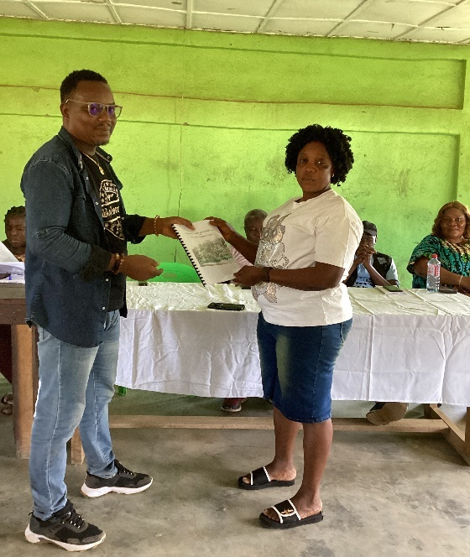  Jenkins Flahwor from the Swedish Embassy turns CFMP to Yassah Gayflor, CFO, Salayea AFC, Lofa County. | 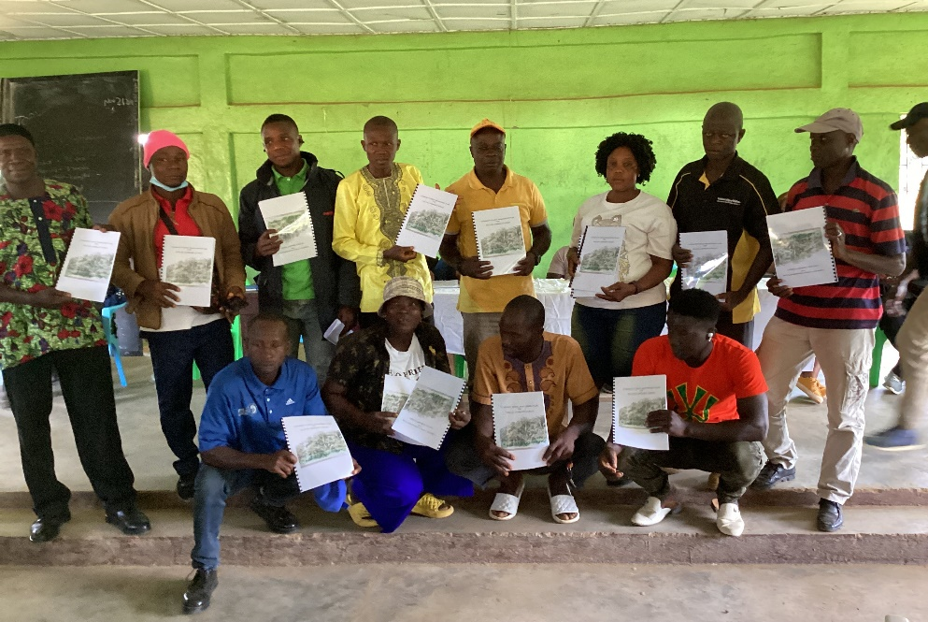  Exuberant Salayae AFC Governance Team assembles for a photo

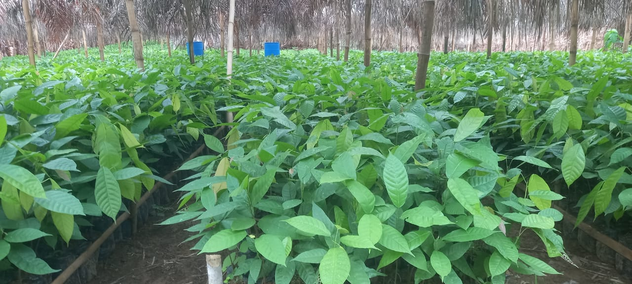
Cocoa seedlings

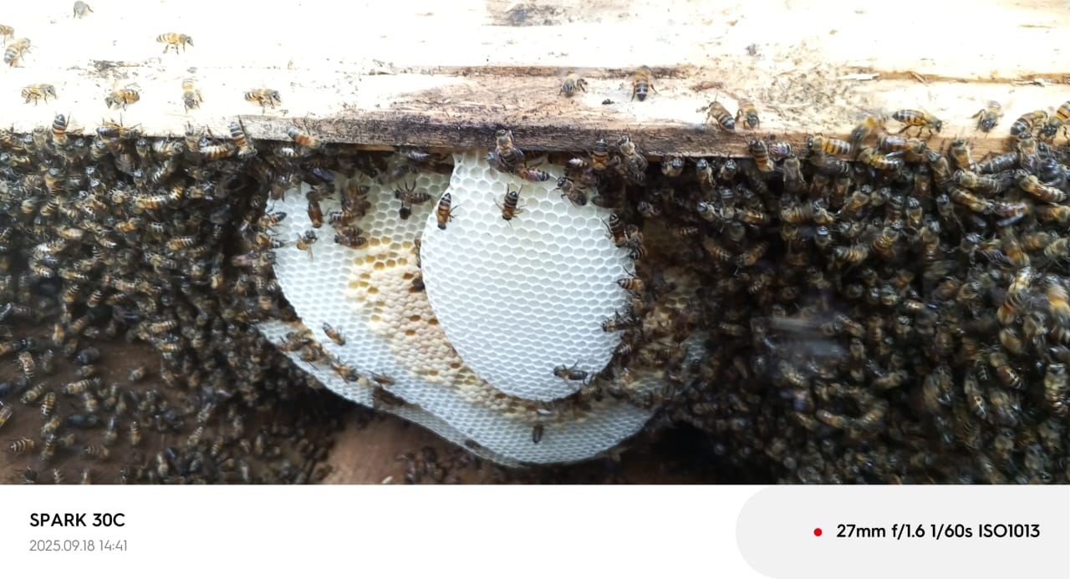
Beehive inspection
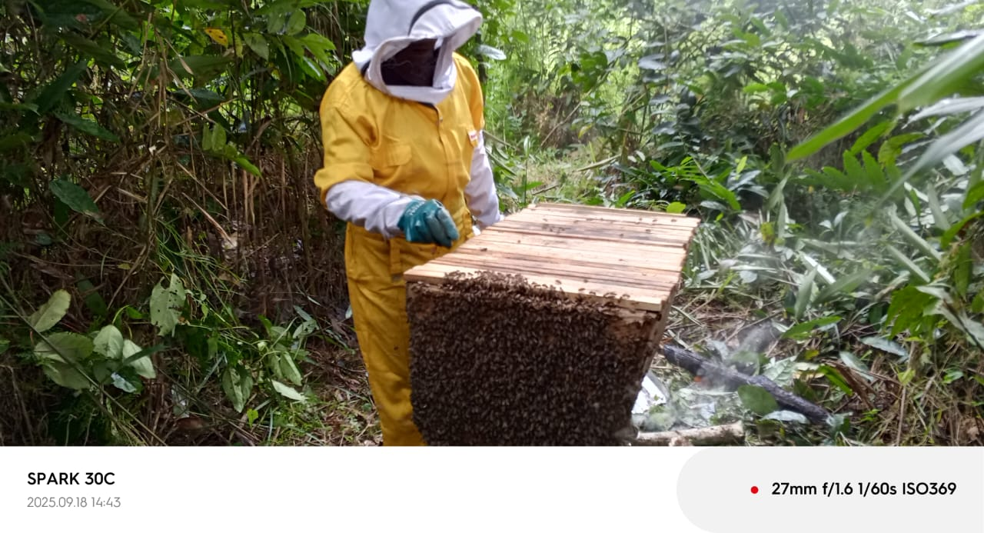

Cane rat rearing to address poaching
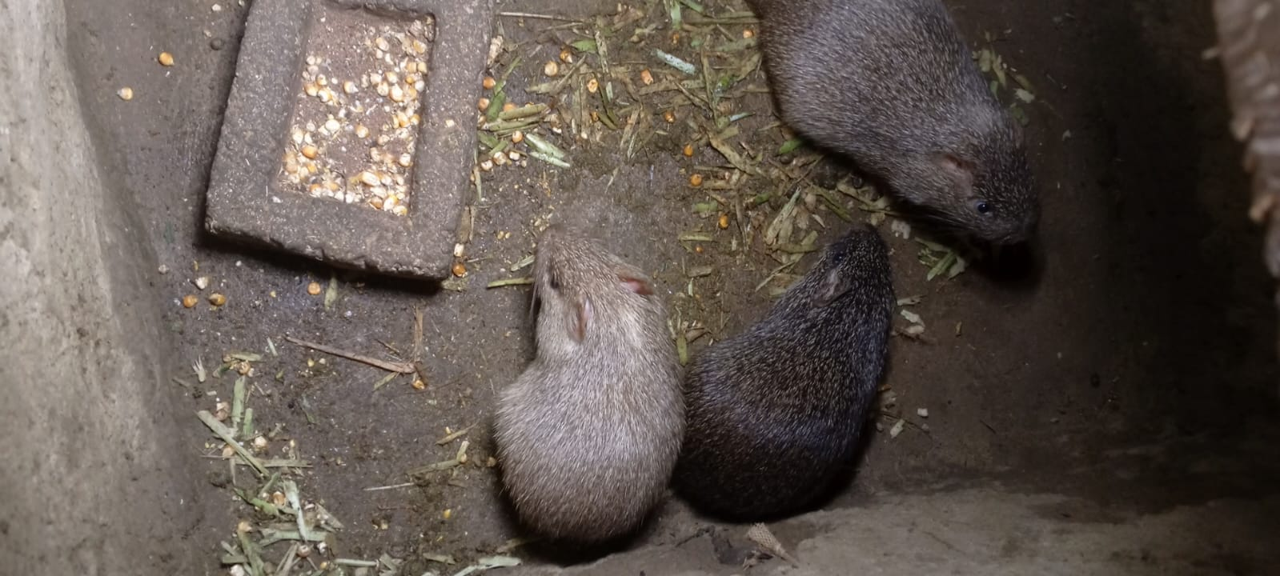
Plantain farm
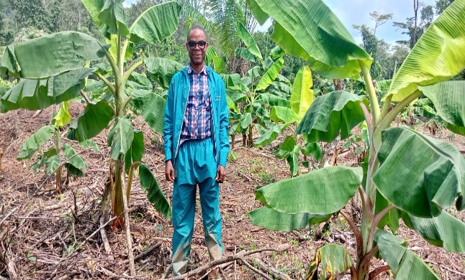

Strategic Results, as formulated in the Strategic UN Planning Framework (e.g. UNDAF) or project document;
The MPTF Office Project Reference Number is the same number as the one on the Notification message. It is also referred to as “Project ID” on the project’s factsheet page the MPTF Office GATEWAY
The MPTF or JP Contribution, refers to the amount transferred to the Participating UN Organizations, which is available on the MPTF Office GATEWAY
The start date is the date of the first transfer of the funds from the MPTF Office as Administrative Agent. Transfer date is available on the MPTF Office GATEWAY
As per approval of the original project document by the relevant decision-making body/Steering Committee.
If there has been an extension, then the revised, approved end date should be reflected here. If there has been no extension approved, then the current end date is the same as the original end date. The end date is the same as the operational closure date which is when all activities for which a Participating Organization is responsible under an approved MPTF / JP have been completed. As per the MOU, agencies are to notify the MPTF Office when a programme completes its operational activities.

